**M.A (Islamic Studies)**

**Ashrafia Islamic University**

**2022**

Reading

Writing

Music

Photography

+92 322 328 6330

saadbadshah7856@gmail.com

**EXPERIENCE**

**EDUCATION**

**HOBBIES**

**CONTACT**

**PROFILE**

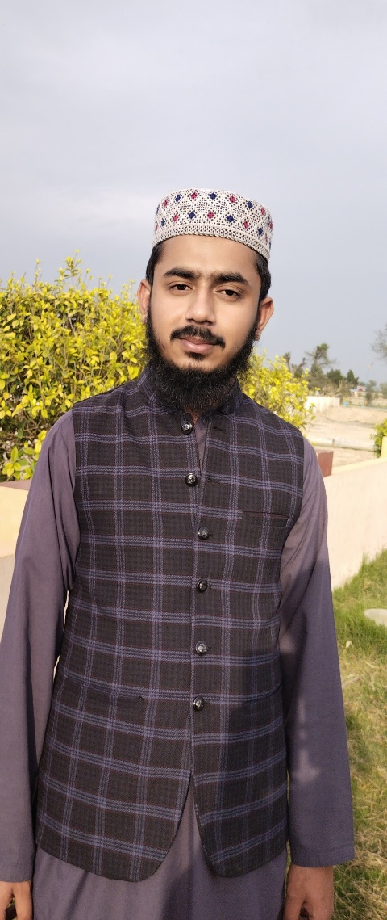

CURICULUM VITAE

**Hamza Shafique**

I am a web developer and web programmer. I design website using HTML, CSS, JavaScript and bootstrap. I have 10-year experience before this in Graphics designing, so this experience will make your website more beautiful.

**ICS (Intermediate in Computer Science)**

**The Hasilpur College of Technology**

**2018**

**Diploma (web development and programming)**

**ISDP (Intensive software development program)**

**2022**

391-mail4.png

067-phone.png

Manzoor Abad, Qaimpur, Bahawalpur, province Punjab, Pakistan

001-home.png

* I have developed 50+ websites using HTML, CSS and JavaScript.
* I have designed 1000+ templets, cards, social media posts, flyers etc.
* I am editing videos for 5 years.

032-book.png016-camera.png

006-pencil.png018-music.png